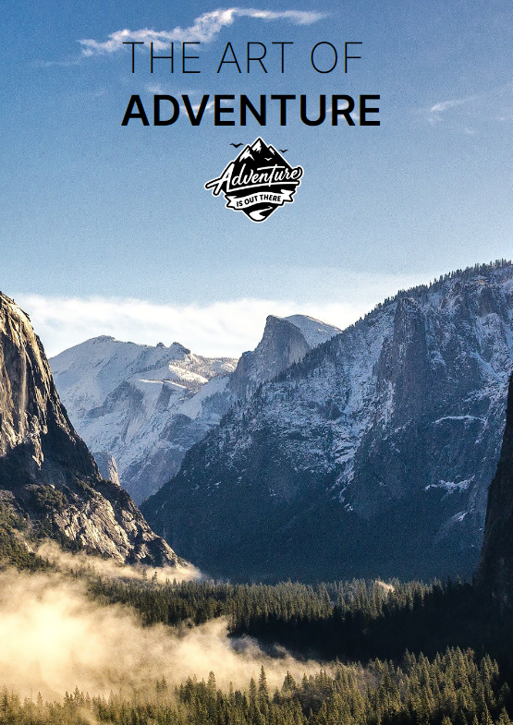

**Project**

**Contenido**

1. Project Description 3

2. Define Project Requirements 4

3. Timeline 5

4. Budged 6

5. Research 7

6. Design principles applied 9

7. Navigation bar 11

7.1 Navigation bar update 11

8.-Prototypes 13

8.1 Sketch 13

8.2 Wireframe 15

8.3. Mockup 19

9. Color Palette 20

10. Typography 22

11. Icons 23

Icon actualization: 23

12. Layout 24

Layout actualization 25

13. Images used 29

14. Project Organization 33

15. Npm 35

16.Accesibility tests 35

17. Link to GitHub Repository 36

# Project Description

This project has been an opportunity to choose any webpage that I would like to design. So I mix two things that I like a lot, Sports and Travels.

Here you will see all the process behind the final webpage and all the decision that I have to take from the beginning to the end. I hope you enjoy this design travel, thanks you for the support.

I have to say that is my first big project of this type and topic. If you have any changing request a supportive comment would be grateful for me to hear it.

# Define Project Requirements

My client is a small travel agency based on my town. it is dependence on another big agency but they want to have their own web page which they really haven`t.

**The website objective** is to catch the attention of the people who want to practice an extreme sport and let them know that they offer the perfect experience for them.

They want an attractive and modern style and design because their principal customers are young people. Their webpage goal is to show all the experiences that they offer for their customers.

They want four different pages:

* **Main** page must have a first fast view of the currently activities.
* **Activities and Travels** page where the people can have a look at all the activities and travels over the world and purchase the one they want.
* **FAQ,** Frequent Asked Questions page.
* **Contact** page where the customers could ask for information to the company.

# Timeline

This planning includes an specific number of hours for each task

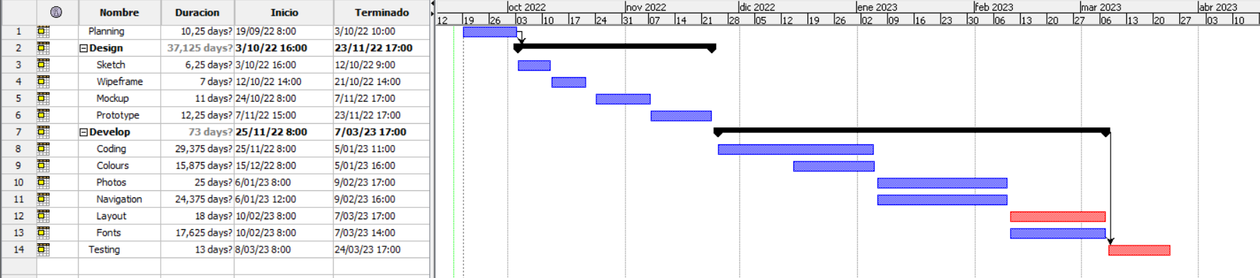

# Budged

The total budget price is chosen according to the hours and cost of each task mentioned in timeline section.

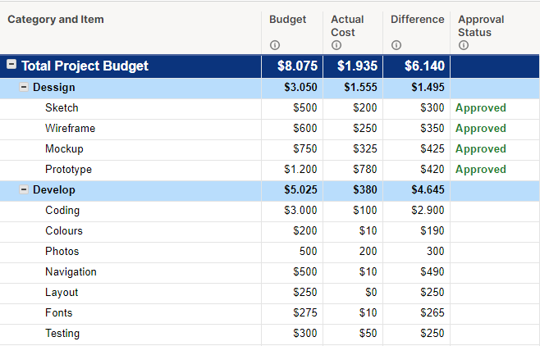

# Research

In other similar websites like for example [Red Bull](https://www.redbull.com/es-es/) it used to have a slicing font of the current events and sports in the main page with a title inside on it. Is a great idea that I will take from this page but without the slicing, only a general font image.

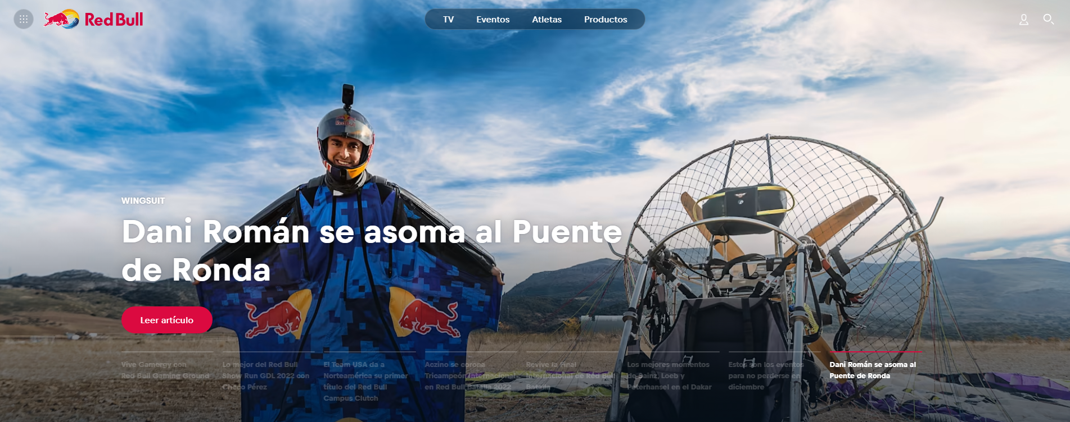

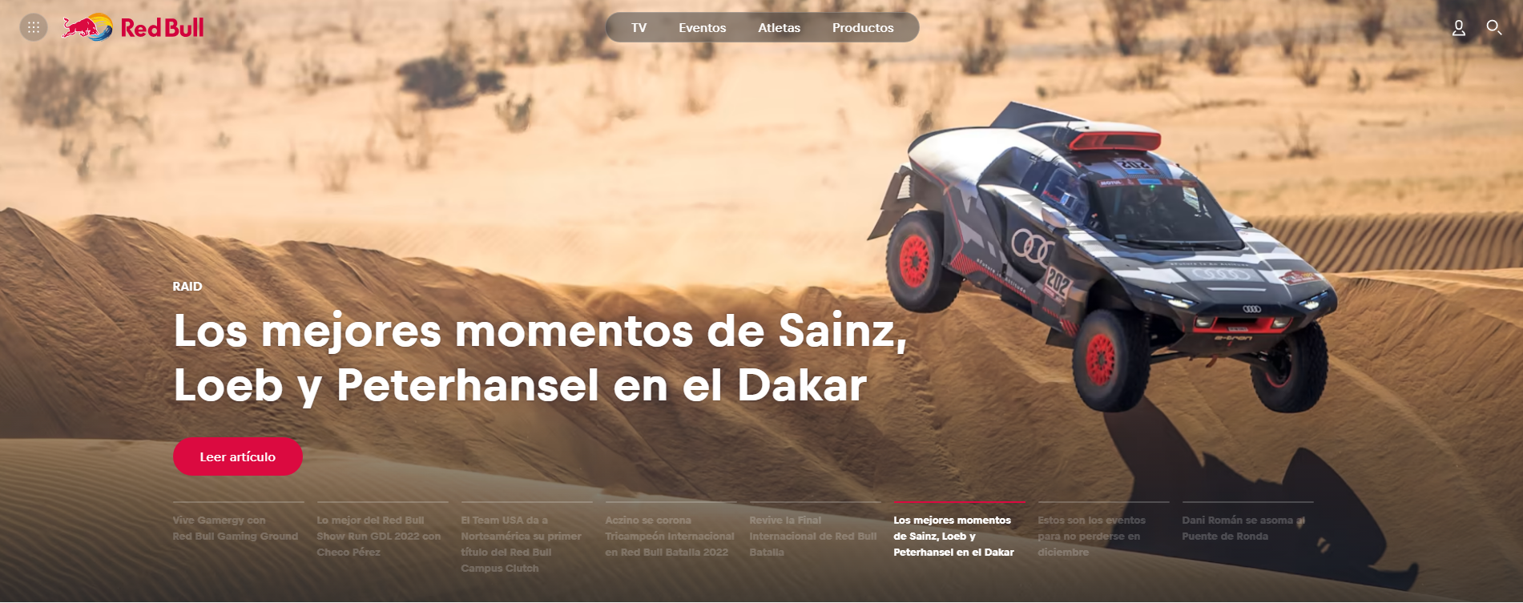

An idea that I will discard is the contact page, I take as example the webpage [extreme.com/contact-us](https://www.extreme.com/en/contact-us/). It seems to be so boring so I want to make my own style, we will see how it turns out.

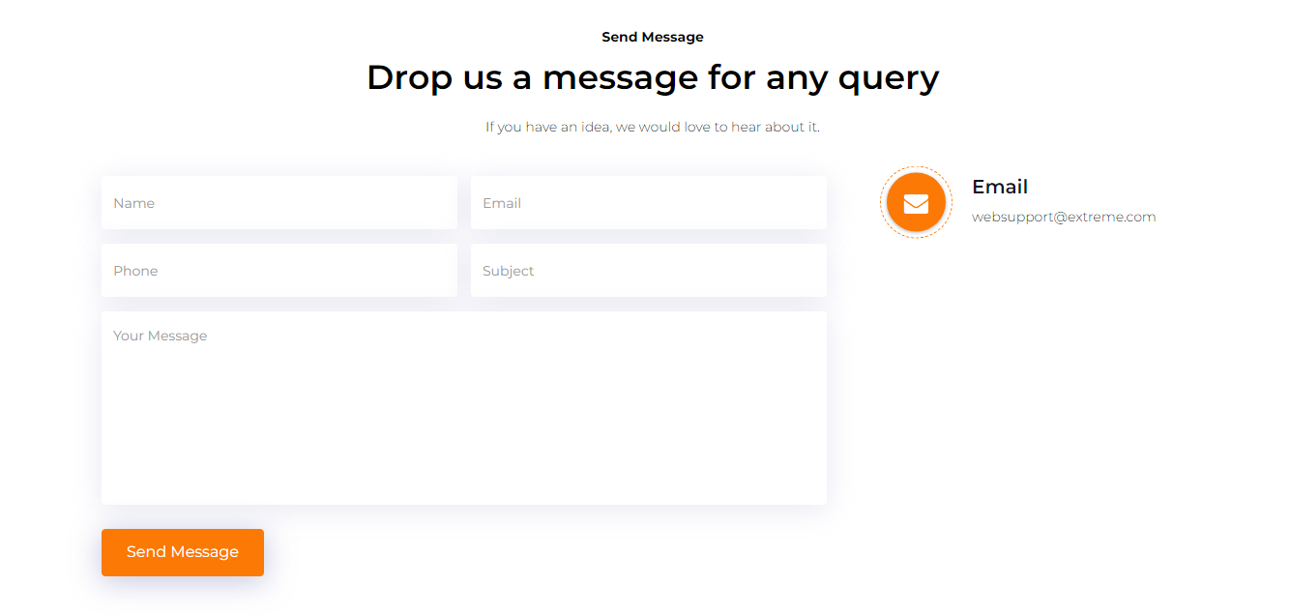

# Design principles applied

1. - Using the ‘Z’ Pattern:

This is when the eye scans from left to the top right, forming an imaginary horizontal line. Them, it goes down to the left side of the page, creating an imaginary diagonal line. Lastly, it trails back across to the right again, forming a second horizontal line.

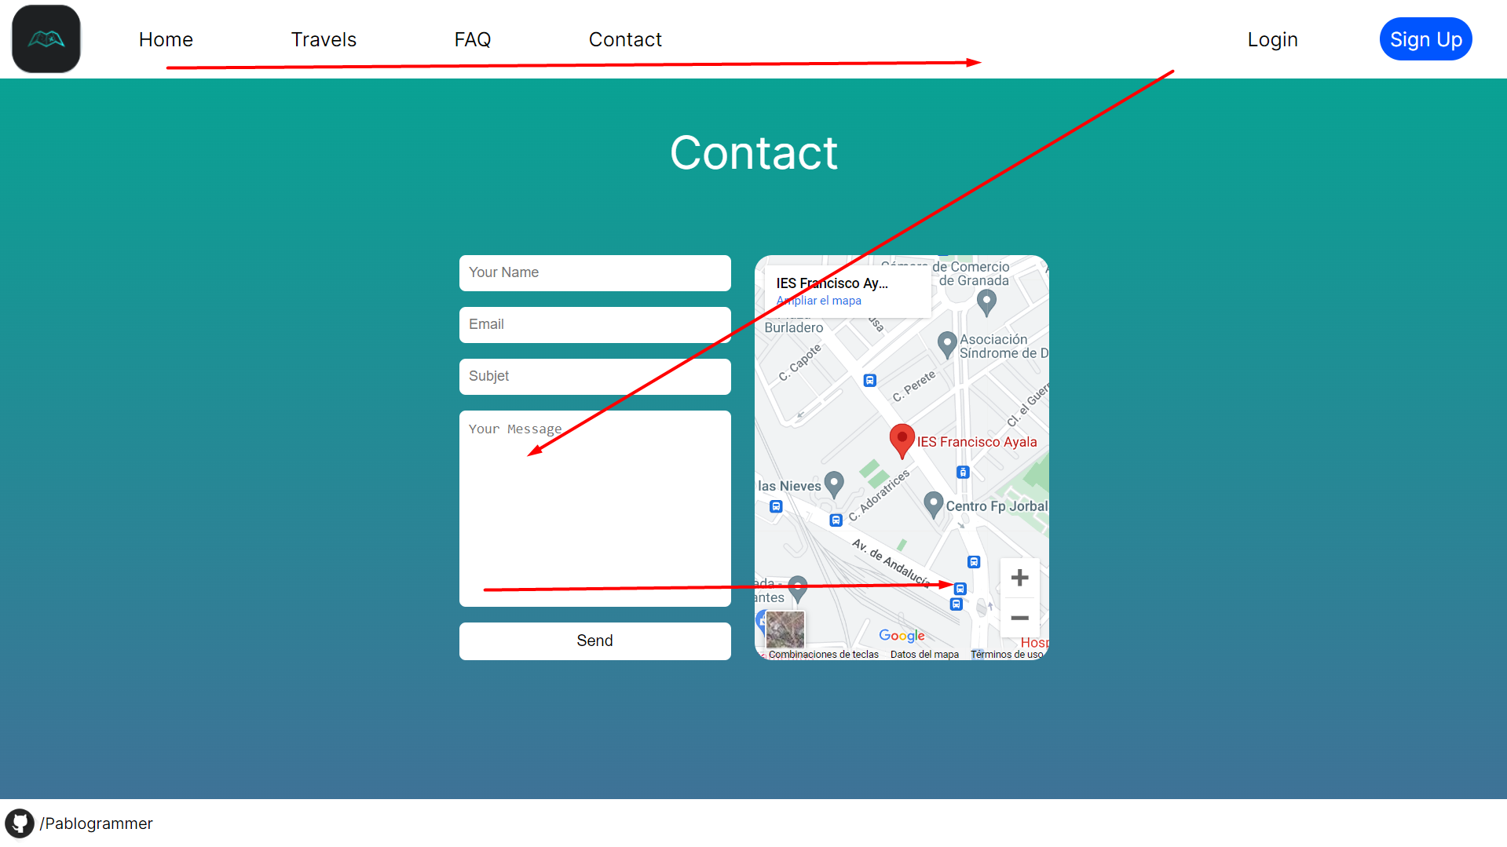

2.- Use negative space:

Sometimes, you can turn a negative into a positive! This is certainly the case with using [negative space](https://www.canva.com/learn/negative-space/) in your website design. Also known as blank space or white space, this is the empty areas between the visual elements in your design (for example, the photos, text and icons)

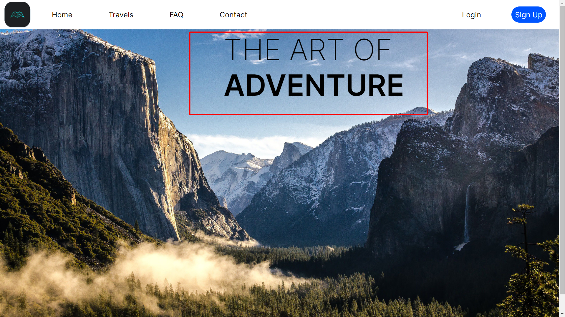

3.- Simple and logical page navigation:

a well-designed website navigation makes for a streamlined and relaxing user experience. This can take many forms—whether it’s a drop-down menu, sidebar or sticky navigation. The key is that it’s easy to locate, works well across all devices and isn’t overloaded with different options.



4.- Optimize buttons and calls-to-action:

While buttons are often the last thing to be added to a web design, they play an indispensable role. They can be the deciding factor as to whether the user continues to navigate your website or closes the window. The buttons on your website should shout, not whisper. That is, they should stand out against the other visual elements on the page and be easy to find and click.



# Navigation bar

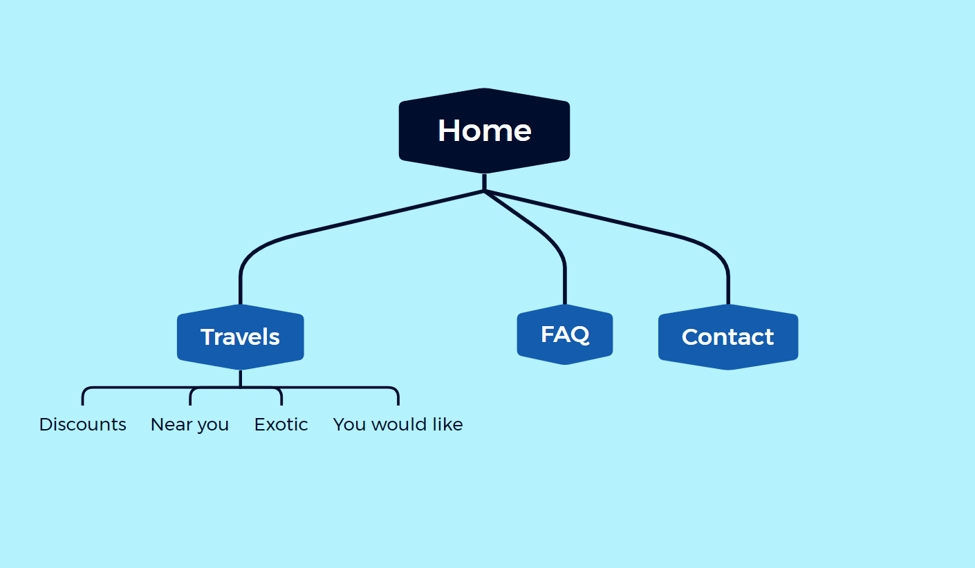

## 7.1 Navigation bar update

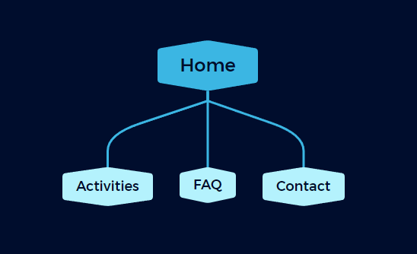

I have to make changes here, so I am going to explain it.

Now the Travels page is not called Travels anymore now has been renamed as Activities because I think it is more appropriate.

for reasons of time I can’t afford the homework of doing all the sub-websites, so all those pages will be removed

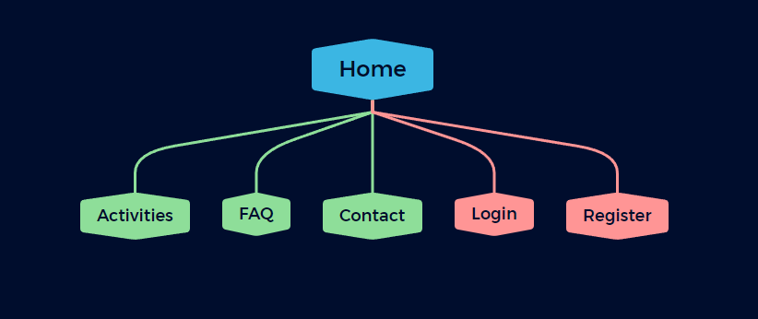

New change and last one. Now I have implemented the login and register form in two different pages, so the navigation bar ends like this.

# 8.-Prototypes

## 8.1 Sketch

Home

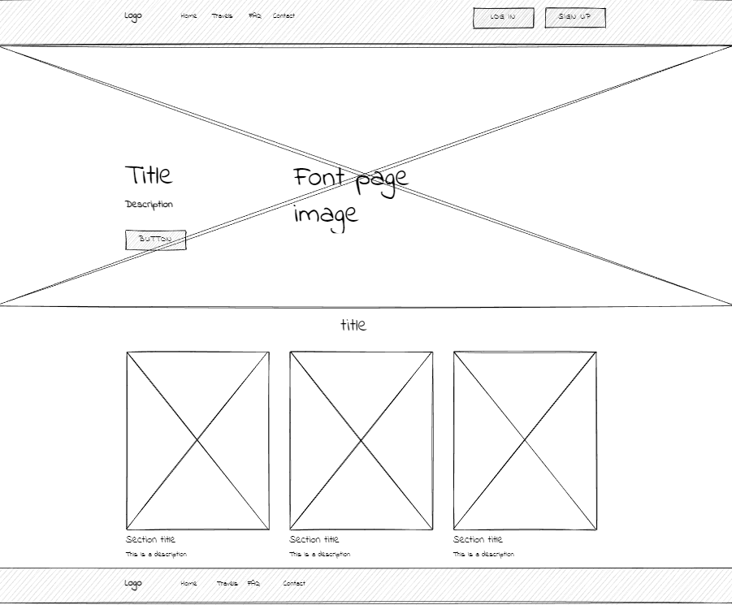

Travels

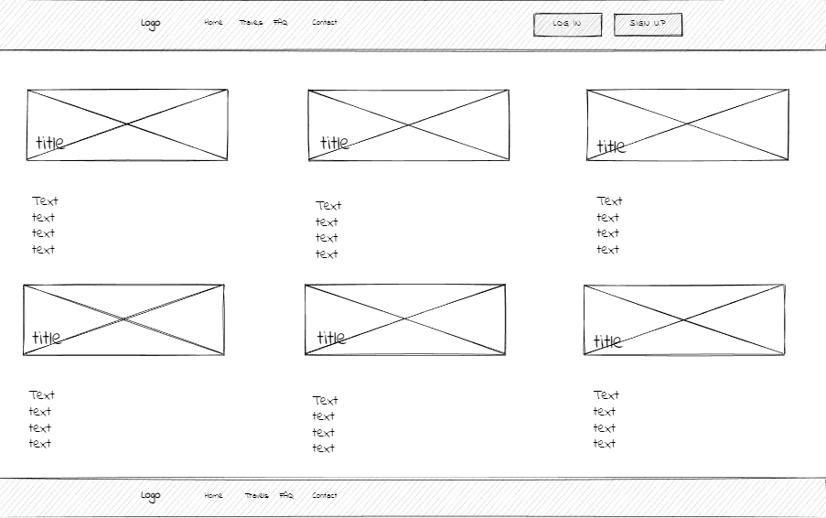

FAQ

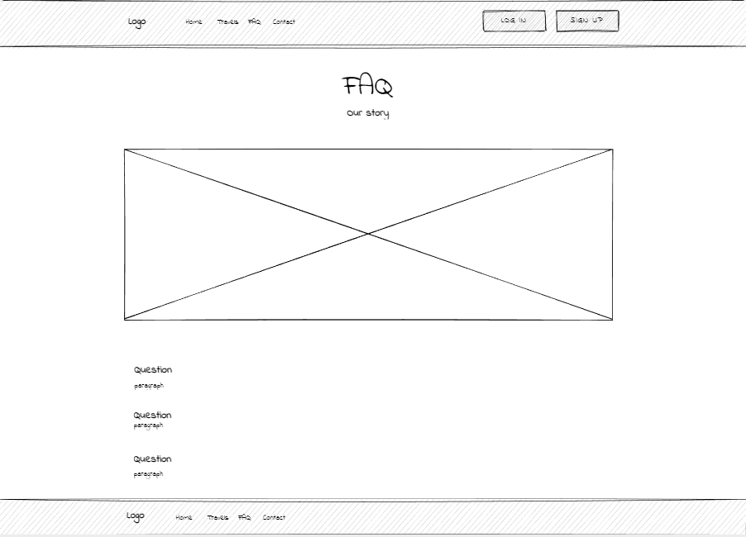

Contact

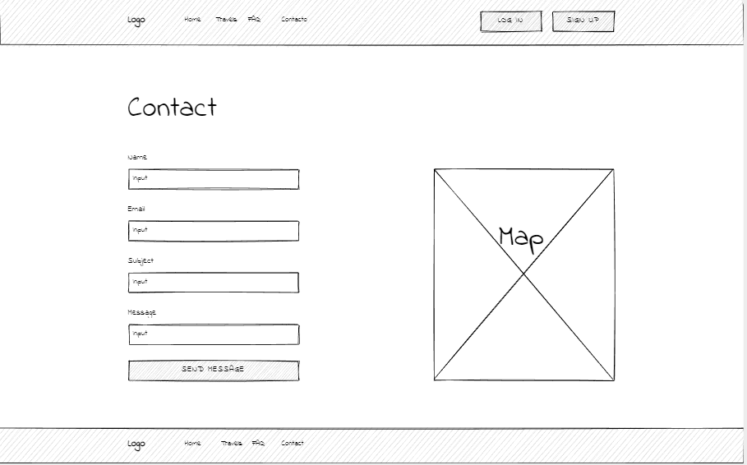

The Client says that there is something that he didn’t like but he wants to keep going to see more result and try to changing his mind.

## 8.2 Wireframe

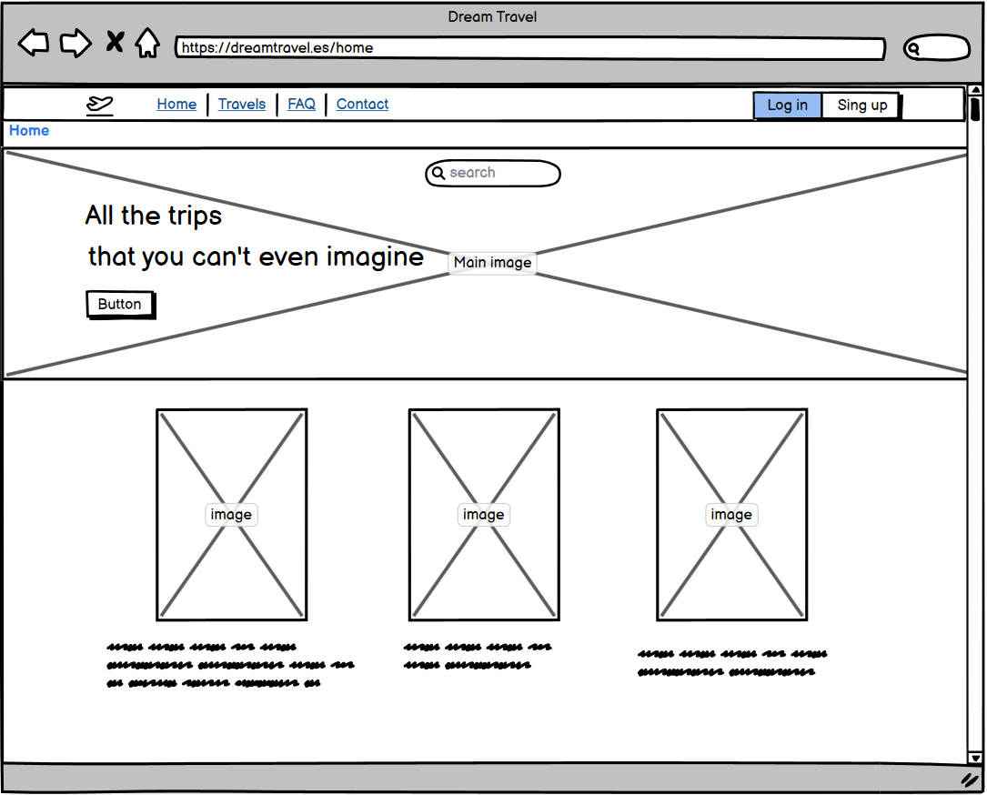

Definitely the problem was here, he says that we don’t need all that’s div under the main page and he didn’t like too the slogan, we need a more simple but effective main page.

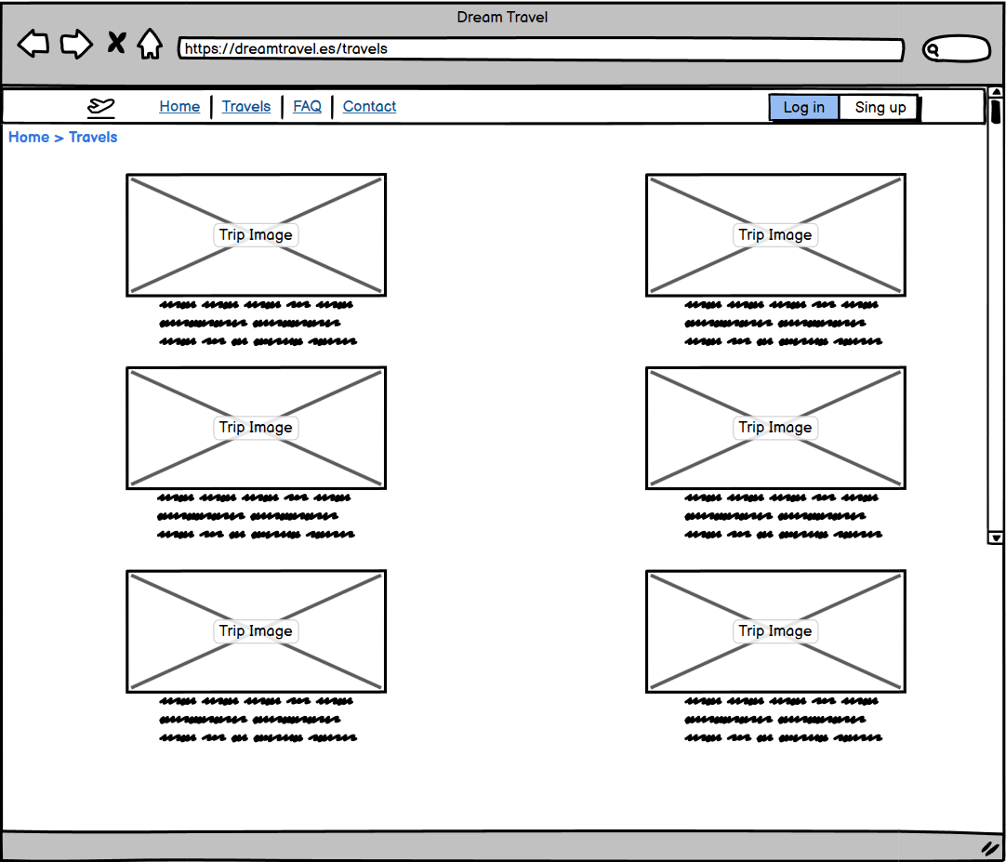

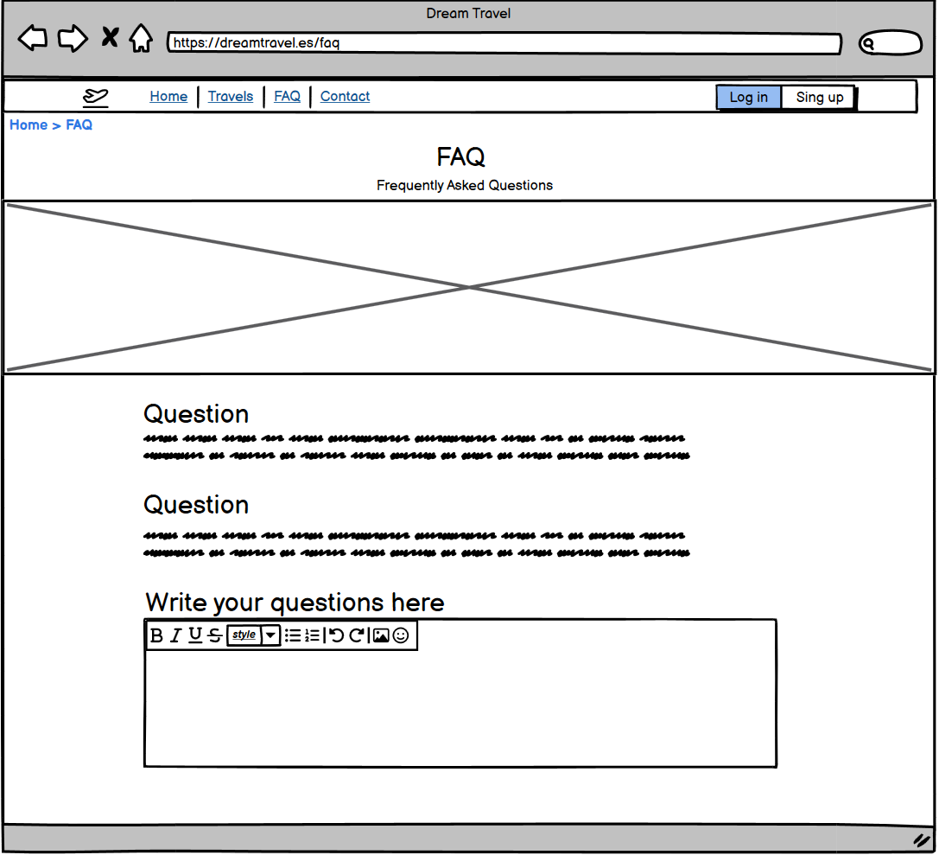

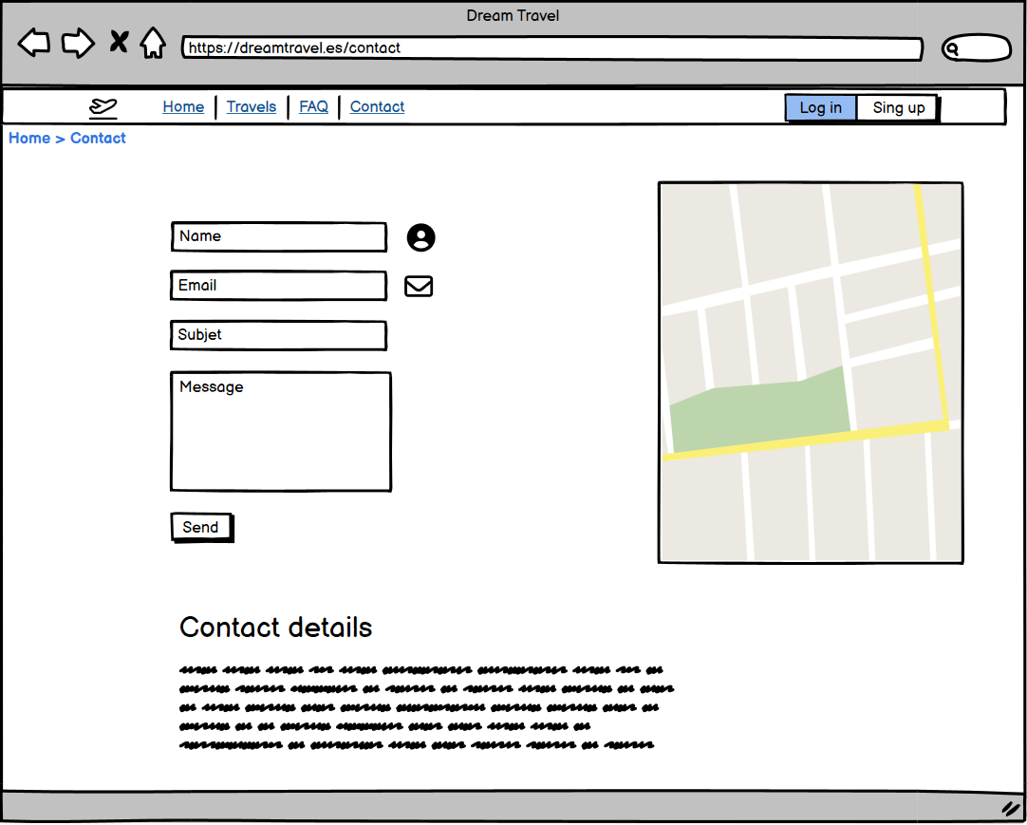

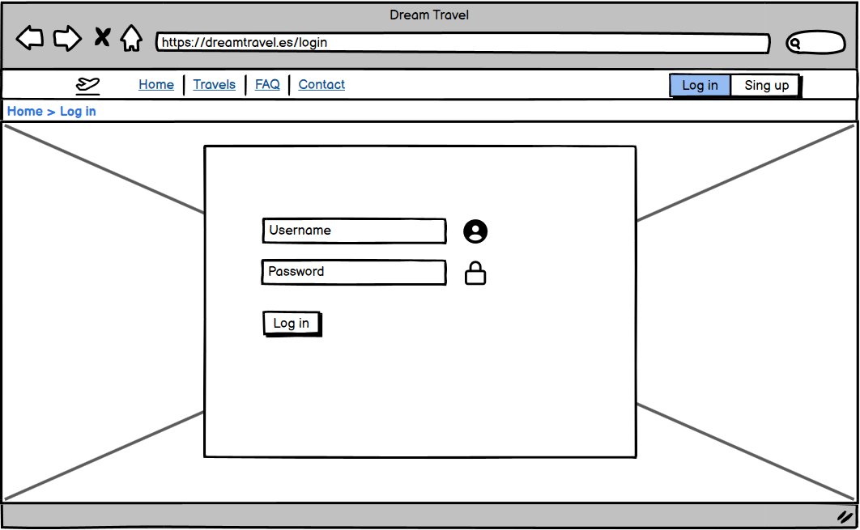

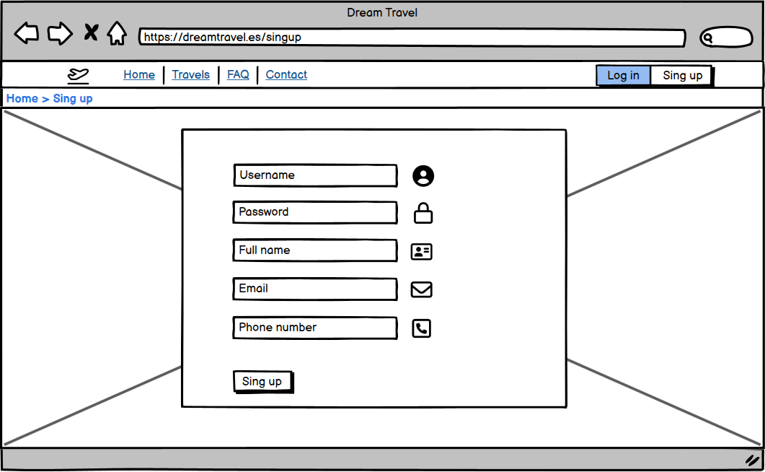

## 8.3. Mockup

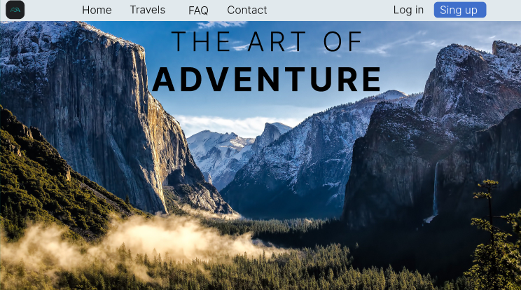

This is the result of The main page, a simple but modern style and a new slogan with more potential

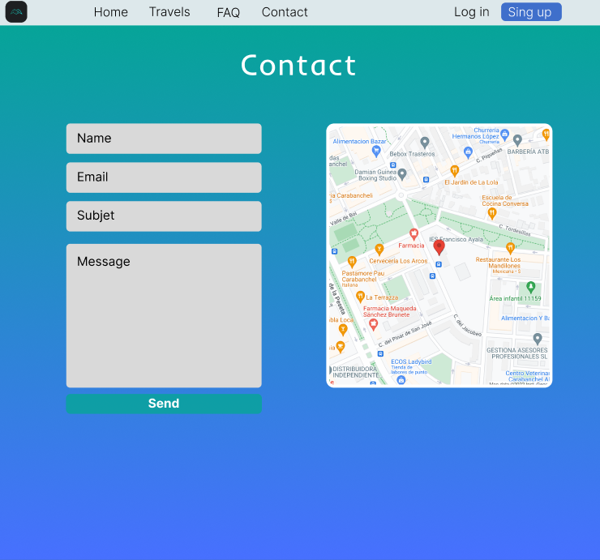

# Color Palette

I choose a tool from [coolors.co](https://coolors.co/) called image picker who select automatically a color palette from a photo.

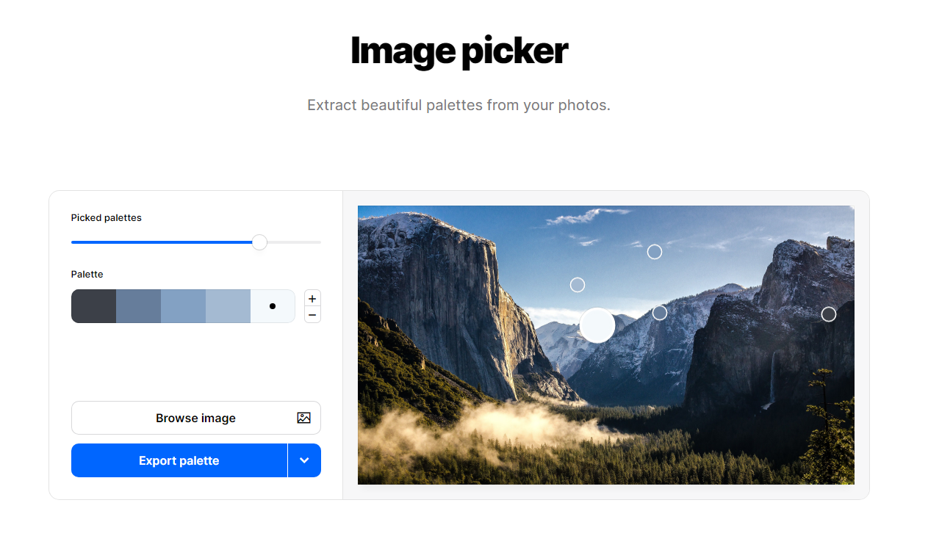

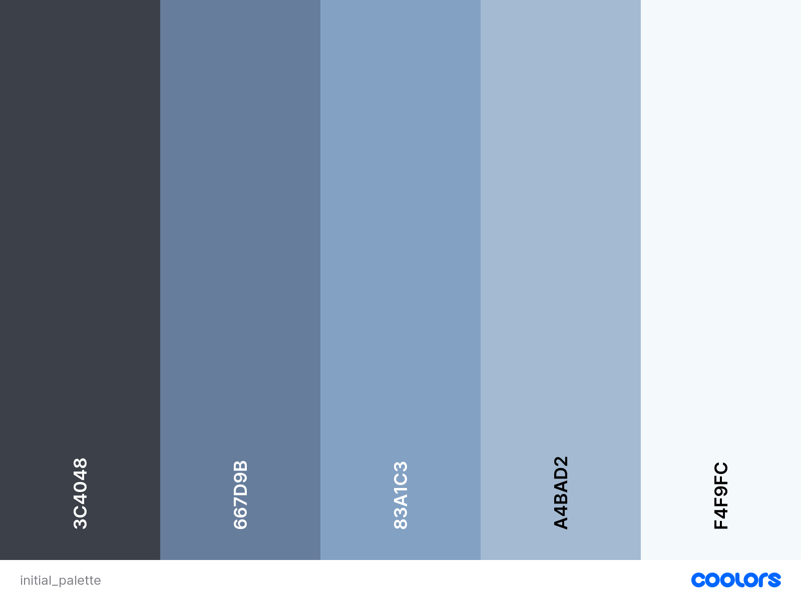

But I didn’t like at all so I decide to personalize it with another tool from the same webpage, palette generator, here I have the freedom to choose any color that I want. I keep some colors that I like but remove others that don’t.

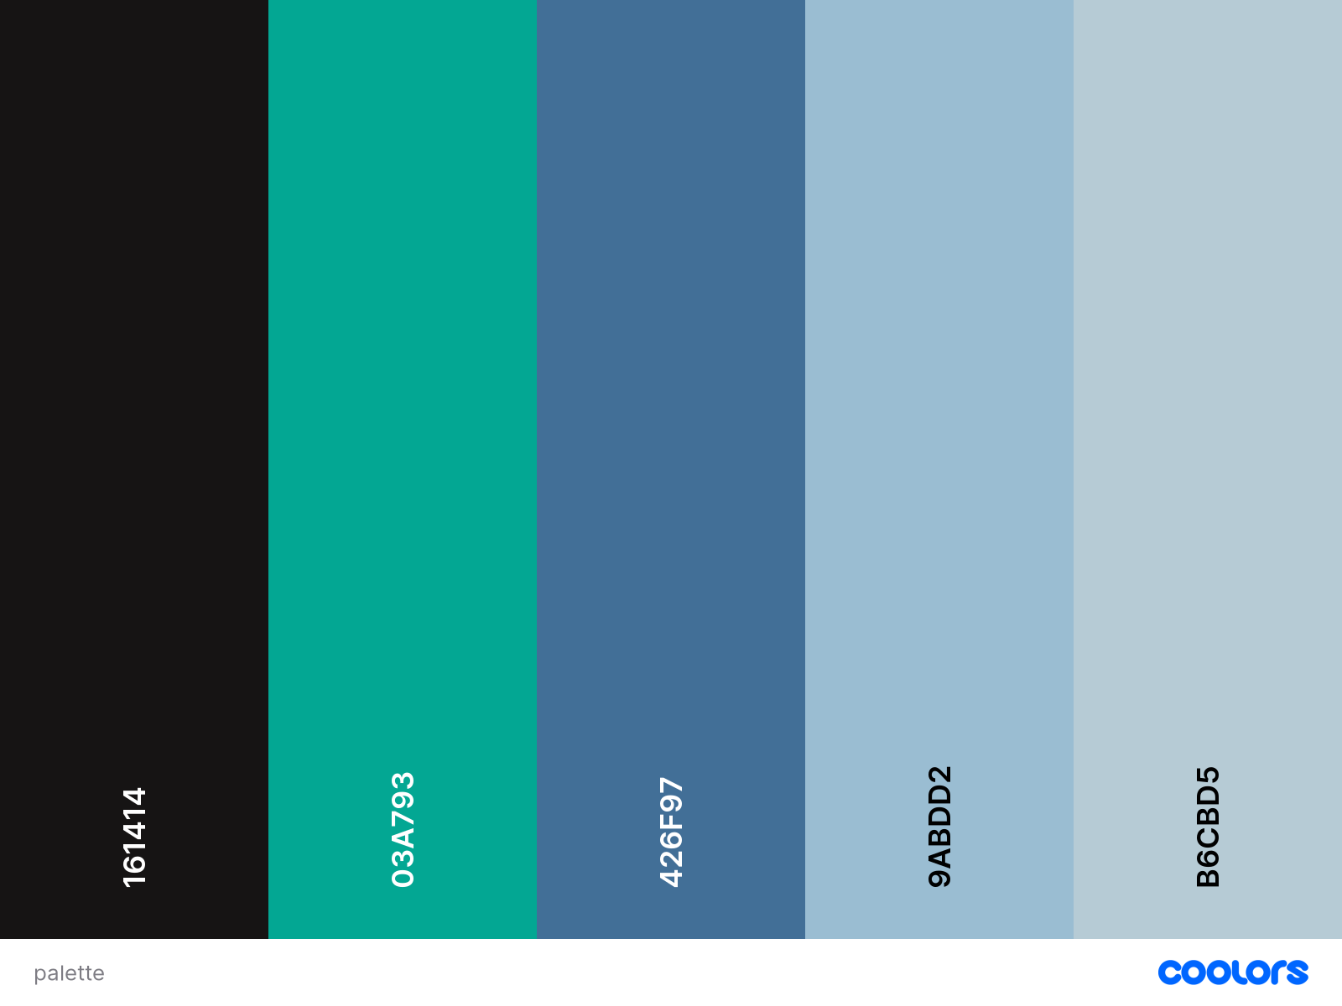

The decision to have a blue-green color on my blue palette is because I wanted to do a gradient in some of my pages so I need to have a striking color so that the gradient looks good, but it still looking professional.

# 10. Typography

**I started from a general typography that I like a lot:**

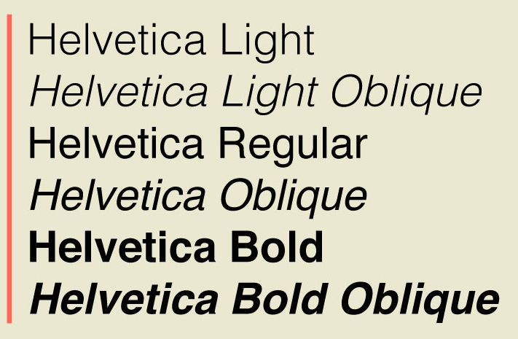

**But I was not convinced a lot so I start to search similar font until I found this:**

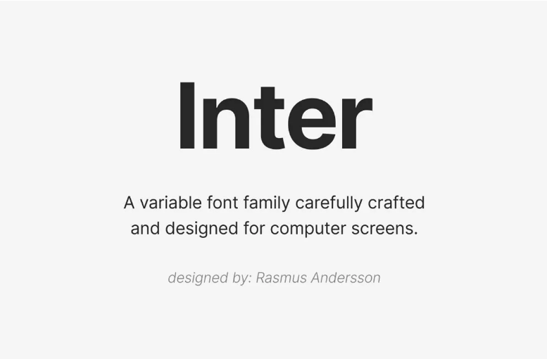

**It still been professional and understandable at the same time, so I’ll keep this one for sure.**

# 11. Icons

The only icon that I have is the logo of the page and the company:



## Icon actualization:

I was not very happy with the result of the last icon so I decided to make a new icon that reflects better the intention on the web.



# 12. Layout

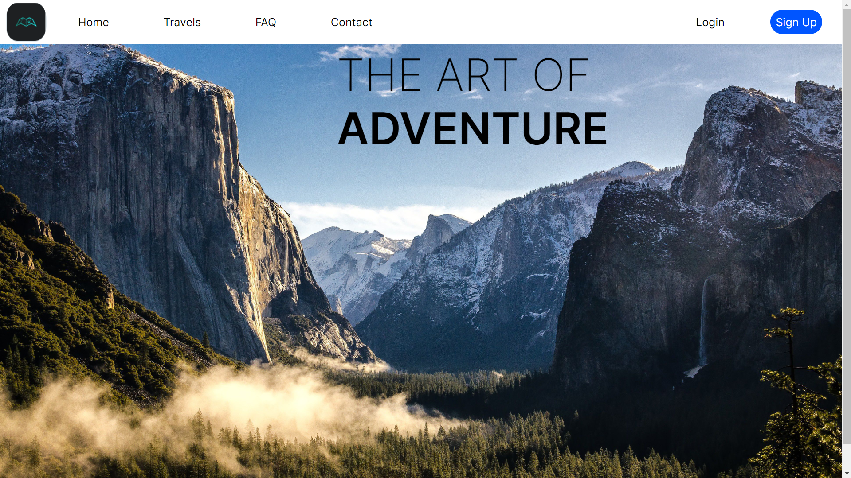

Here I have used the in common part which is the header. And I have use an image as background with the slogan on it. I have used absolute display for the header, and for the text. The page seems to be simple but very professional and with a modern and safety style.

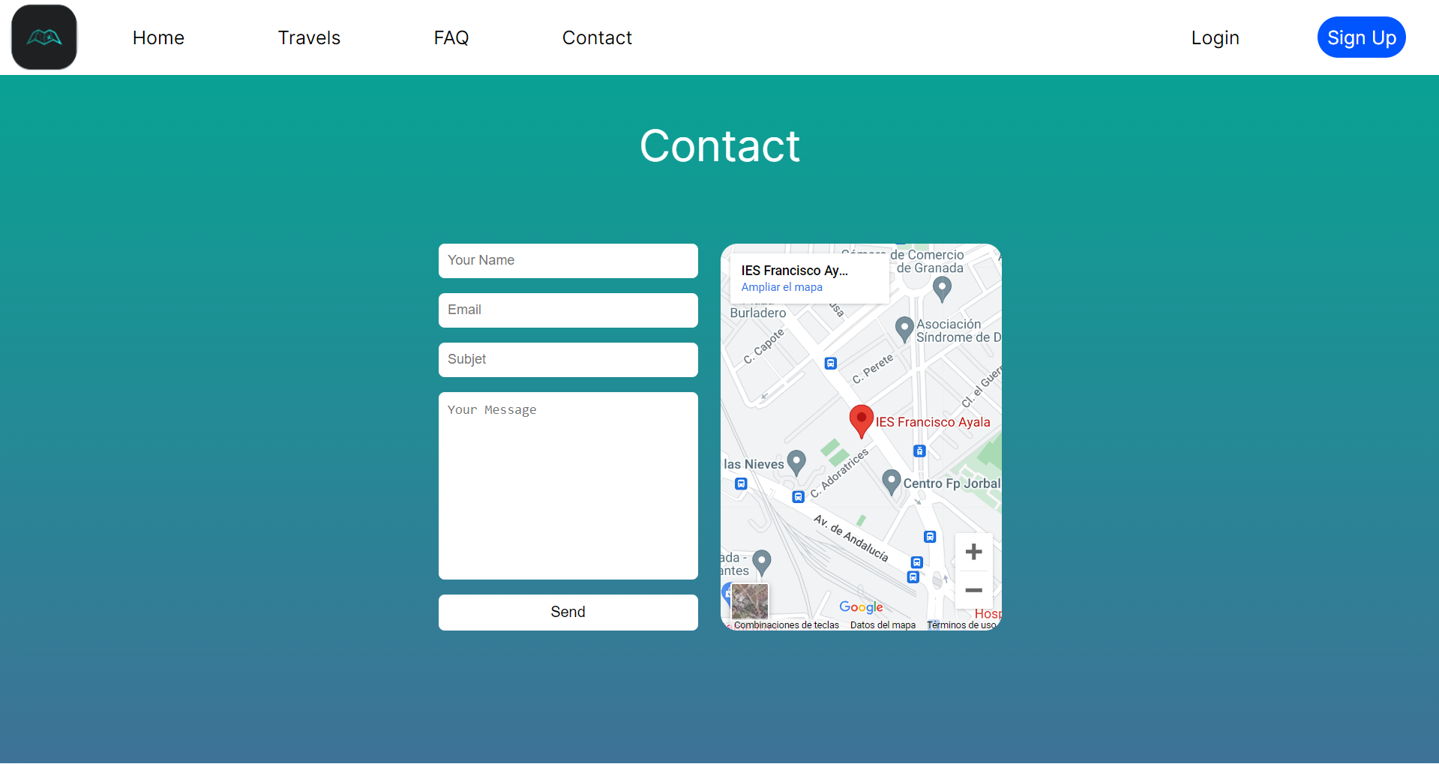

In the contact page I have use a general div container with all the layouts and the map including on it but separated in two different div at the same time. I have used flex display for all the form. In this way it seems to be very professional and simple.

## Layout actualization

**Note:** Now all the pages are responsive so we can saw them in different devices. I am going to show them in PC dimensions but you can saw all the dimensions downloading it directly in my Github.

I recommend to watch the final webpage in Firefox browser, I do not know why but the page works perfectly there but not in other browsers like Google Chrome or Safari.

Index

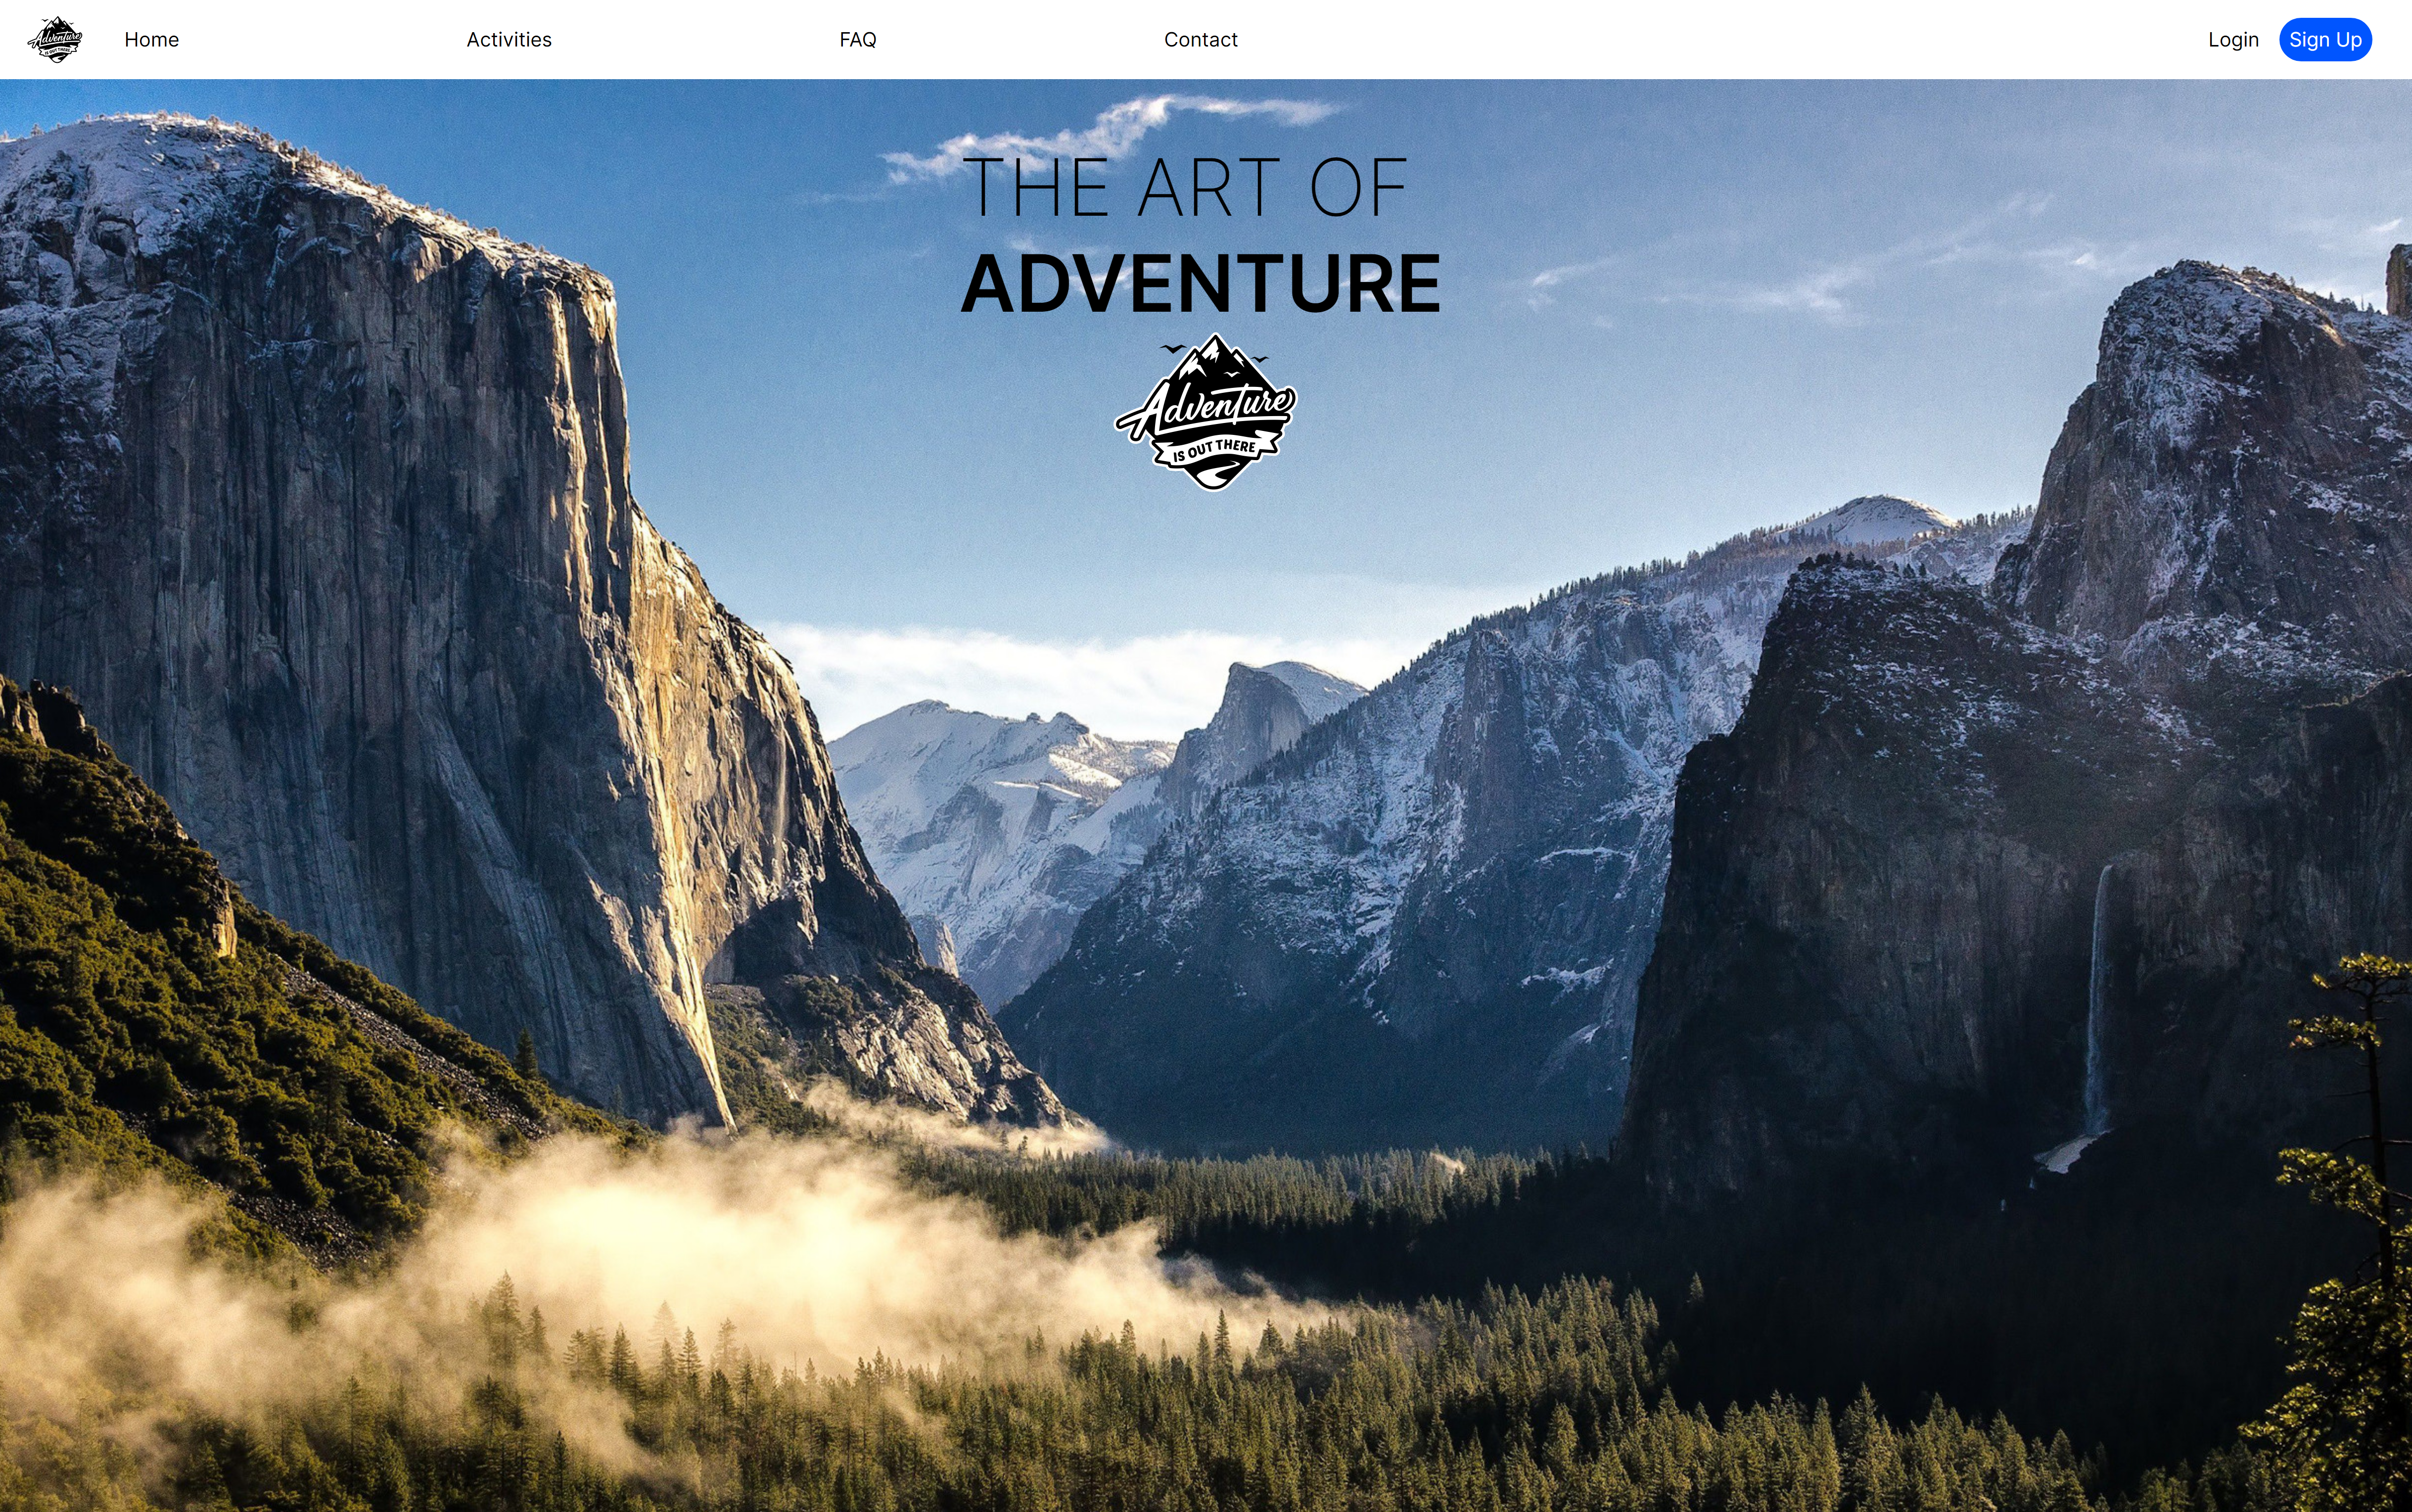

I have decided to include the Icon in the main page and expand the image on the background. I have to say that fully sized seems better than here.

Activities

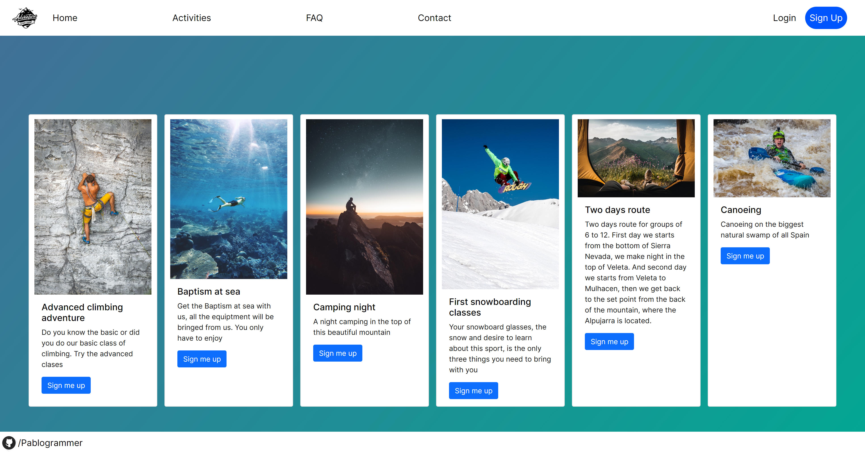

Activities page has been done already. I used Bootstrap here but is not too friendly with my own css and for example the Sign Up link don’t have the same style than in others pages.

FAQ

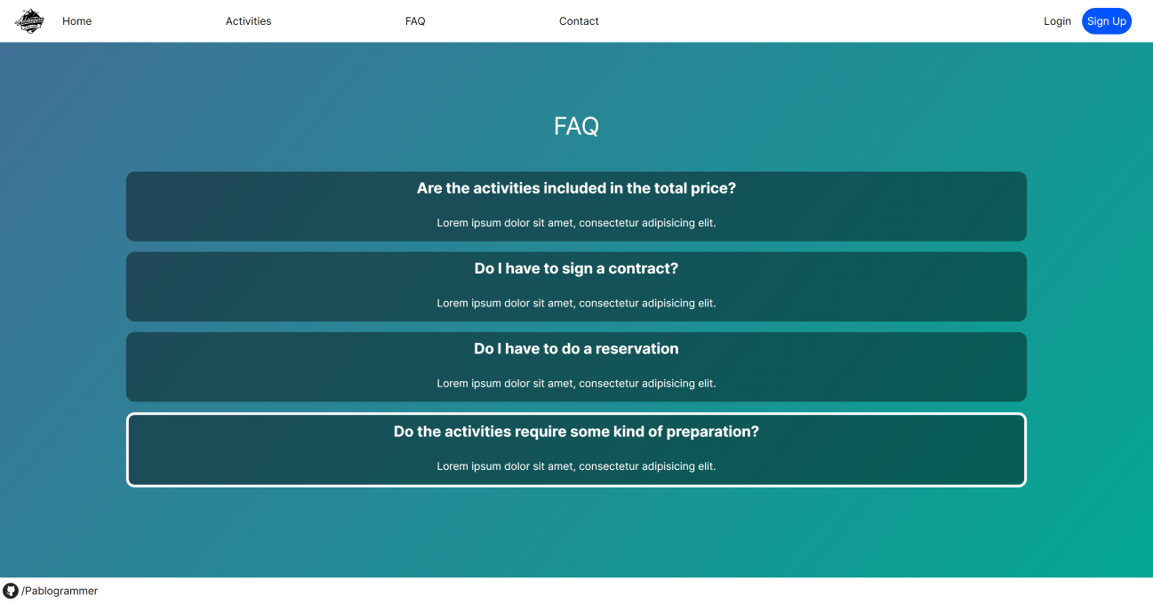

Now the Frequently Asked Questions is finally done and working with JavaScript included

Contact

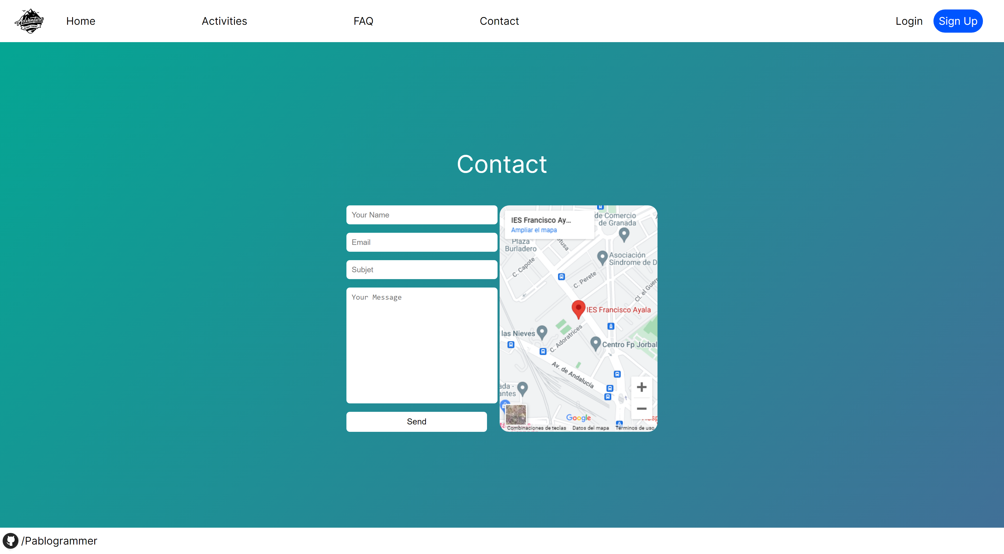

Some little changes of styles

Login

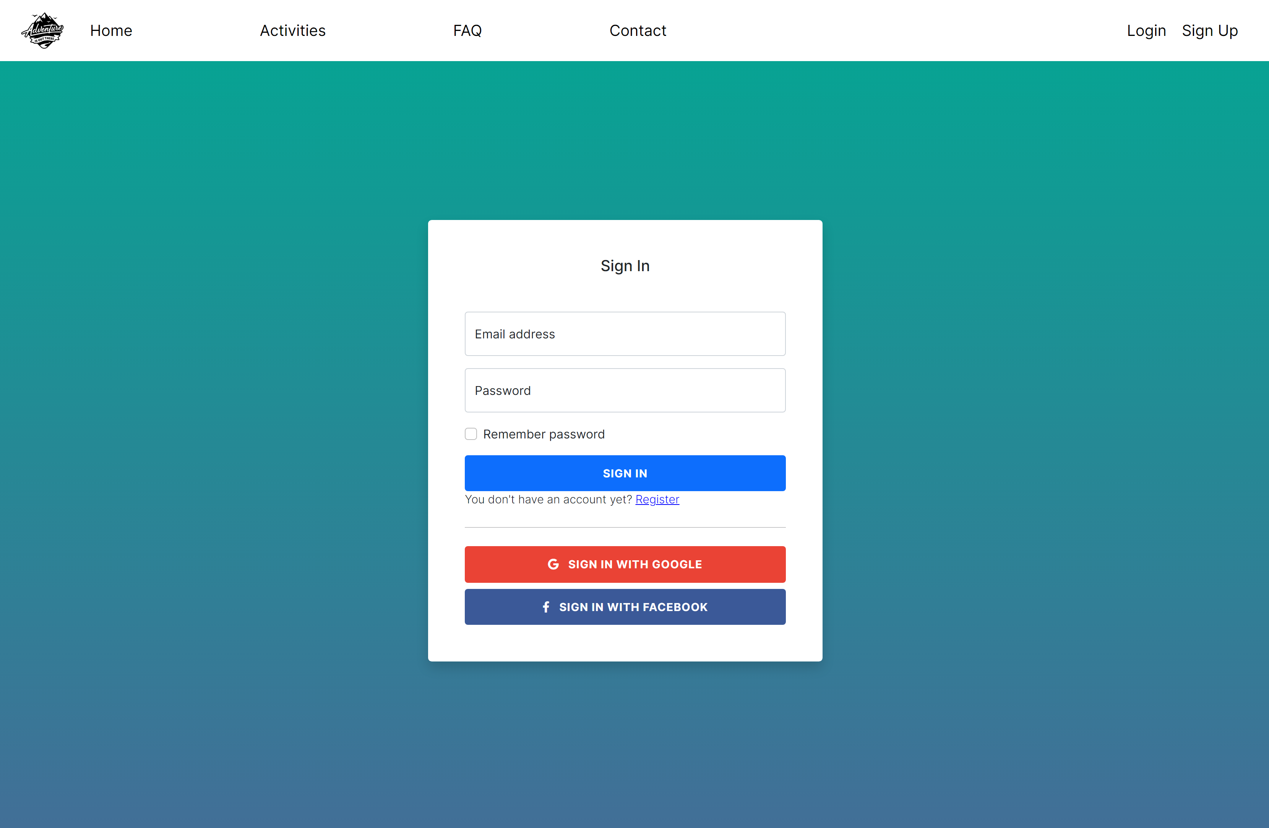

This has been made with Bootstrap and like I said in the FAQ page bootstrap is not too friendly with my own styles

Register

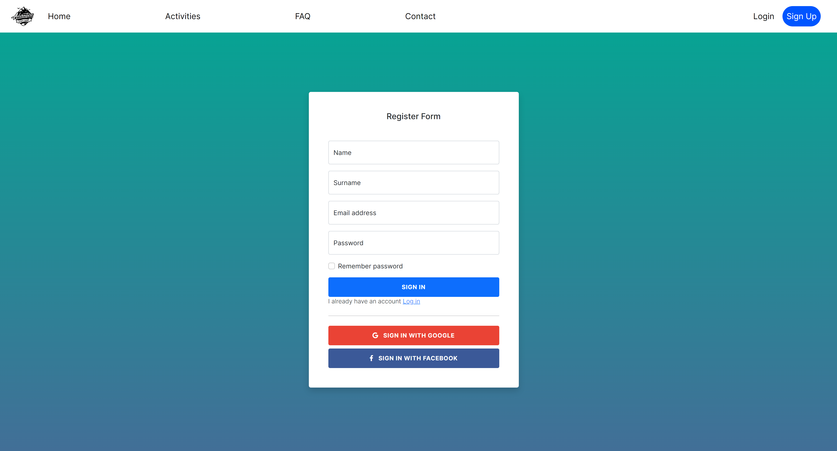

This is the last page that I implemented, It is done with Bootstrap as well as the login.

# 13. Images used

Here I am going to explain all the images used and for what I used for each one, all the images has been resized with GIMP in different dimensions (300px, 700px, 1000px, 1600px) and I use them depending on the device where you are using.

**Main background image:** This image is the main one because it is used in the Home background. It is a free use photo and I found it on a Reddit page called [r/wallpaper](https://www.reddit.com/r/wallpaper).

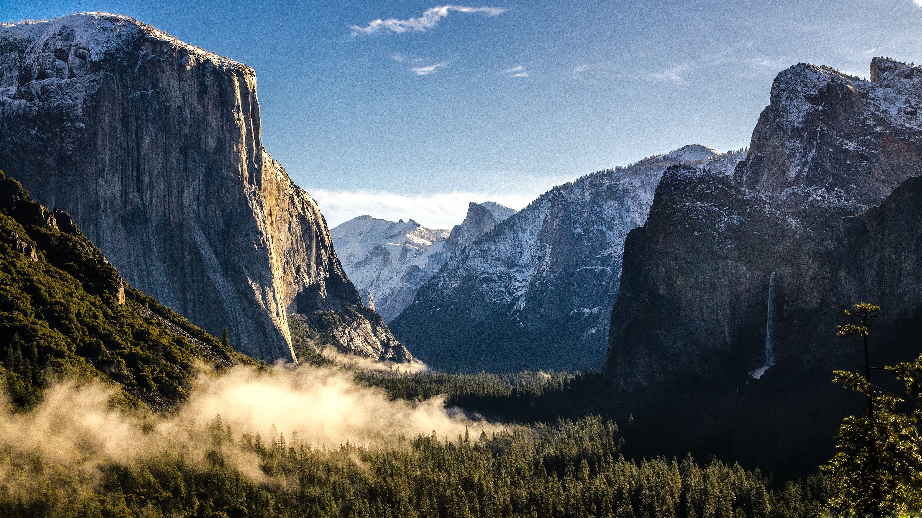

Original Resolution: 3840 x 2160

Size: 2 MB

[Link](https://www.reddit.com/r/wallpaper/comments/iwfyl8/mountain_3840x2160/?utm_source=ifttt)

**Logo:** This is the logo of the web and I took this photo from a webpage called [pngeeg](https://www.pngegg.com/es).



Original Resolution: 800 x 660

Size: 72,6 KB

[Link](https://www.pngegg.com/es/png-kqfyy)

From this point all the images has been taken from **Unplash**, Is a web that born in 2013 like an album blog. Now is much more and I highly recommend this web here you have the link if you want to take a look: [Unplash.com](https://unsplash.com/es)

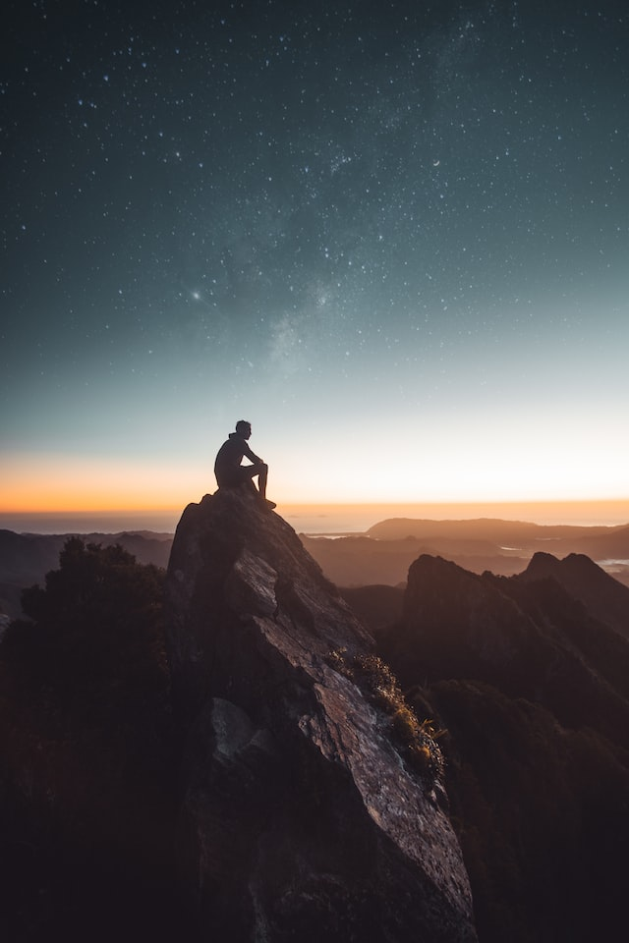

Original resolution: 640 x 960

Original size: 54,8 KB

[Link](https://unsplash.com/es/fotos/__I-gX-cnd8)

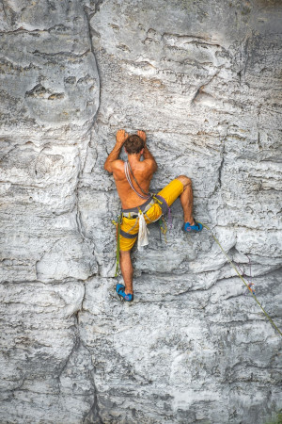

Original Resolution: 640 x 960

Size: 209KB

[Link](https://unsplash.com/es/fotos/YqVDdDkdFkw)

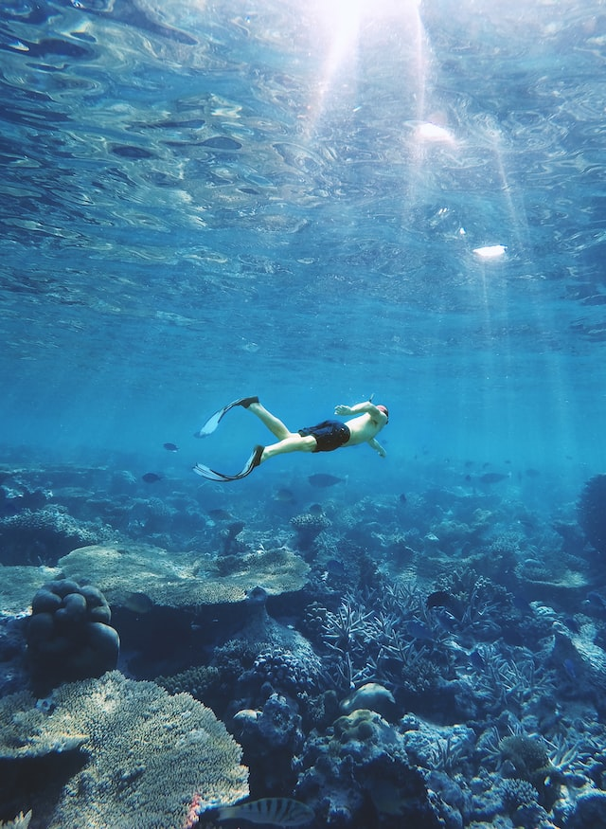

Original Resolution: 640 x 875

Size: 138KB

[Link](https://unsplash.com/es/fotos/3wb4KYqGXLU)

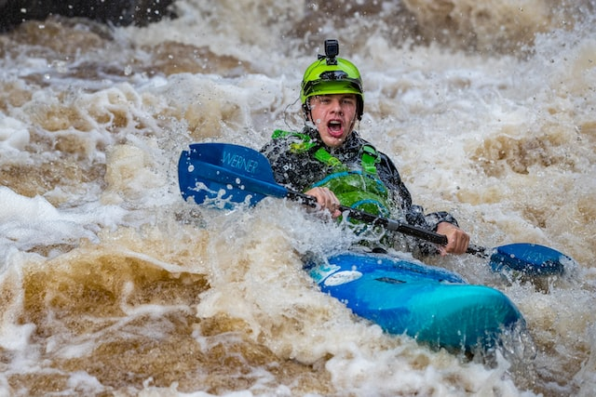

Original Resolution: 640 x 427

Size: 74,4 KB

[Link](https://unsplash.com/es/fotos/ECXHCQwzKx8)

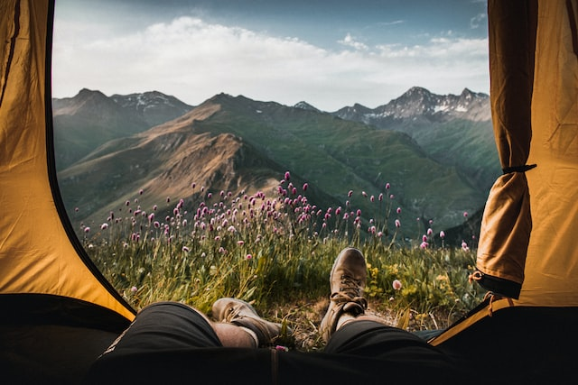

Original Resolution: 640 x 427

Size: 64,2KB

[Link](https://unsplash.com/es/fotos/re2LZOB2XvY)

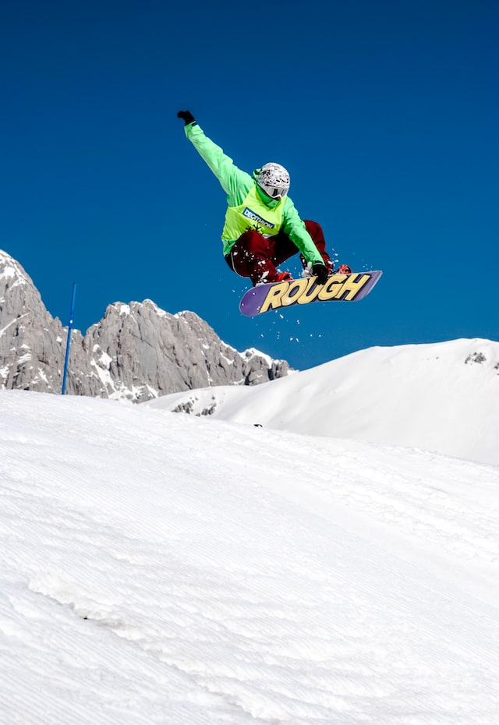

Original Resolution: 640 x 930

Size: 68,6KB

[Link](https://unsplash.com/es/fotos/OKBP1D8Wr4c)

# 14. Project Organization

In My project I have a structured formed with 4 folders (html, images, scss and scripts). The index.html is located at the root of the project.

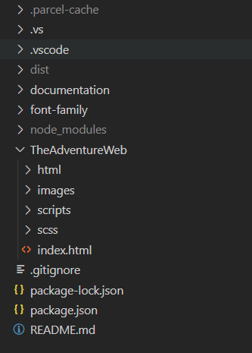

**.parce-cache**, **dist** and **node_modules** are included in the file .**gitignore** so those folders are not in **github**.

Inside the **documentation** folder you can find the documentation of and the follow-up of this project since the beginning.

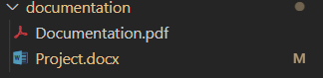

In the **html** folder I have all the html files of my web, 5 without the index file so 6 in total.

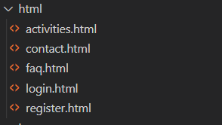

In the **images** folder I have all the images used in the web.

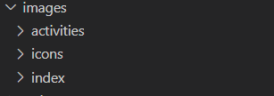

The **script** folder is where I have the JavaScript files used in my web.



In the **scss** folder you can find all the styles applied on sass coding. The main.css file is the only one tied to each html files.

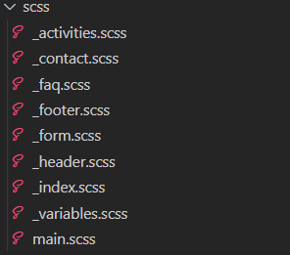

In the **font-family** folder (outside the main web folder) is the “Inter” typography in case you like to download it, but in the code I use the Google Fonts API because is faster in terms of rendering and easy to use so I don’t need it, is only for your commodity.

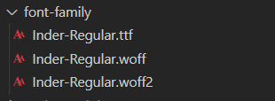

# 15. Npm

# 16.Accesibility tests

I have used <https://accessibilitycheck.org/> and here you have the results.

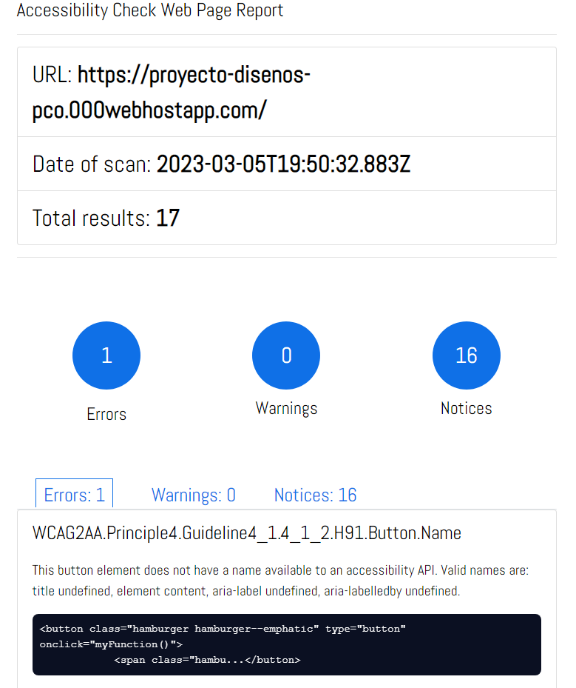

The Error that I have is refered to the hamburguer that appears on the nav menu when the resolution is under 800px and is a thing that I copy from internet so is not my fault at all.

# 17. Link to GitHub Repository

Take a look to the project in GitHub with this link:

<https://github.com/Pablogrammer/Design_project>